To Set up the Grid on the MAC

First-if you have a split view (2 worksheets) change to full normal view
View→ Normal

- Select the whole worksheet
- Go to Format→Row→Height
- Enter 0.25
- Click OK
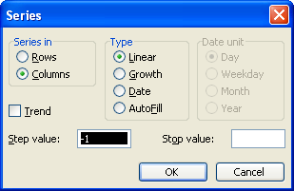
- Go to Format→Column→Width.
- Enter 0.25
- If the screen or grid is still too small for you-use the zoom feature and increase size to 150% or 200%
- Click OK Your grid should now look approximately square. You can change the numbers if you wish. It is dependent on the font you are using.]
- In Cell A3 type, 20
- In Cell A22 type 1
- Highlight Cells A3 to A22
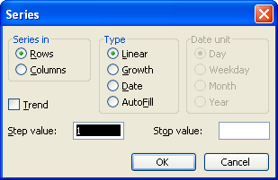
- Click on Edit→Fill→Series. The popup box should be as shown.
- Click OK
- In Cell B23 type 1
- In Cell X23 type 23
- Highlight Cells B23 to X23
- Click on Edit→Fill Series. The popup box should be as shown
- Click in Cell A1
- Type: Plot the Points on a Grid
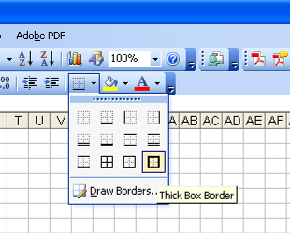
- Click in Cell N1:
- Type Name:
- Highlight cells B3 to X22
- Click on Thick Box Border as shown in figure.

